Effingham Regional Growth Alliance – State of the Region Webinar
Attribution, Supplements, and Further Reading
Images:
Effingham Regional Growth Alliance: http://www.groweffinghamcountyil.com/
University of Illinois – Farmdoc DAILY: https://farmdocdaily.illinois.edu/2022/08/farmland-prices-higher-but-still-in-line-with-market-fundamentals.html
Shelby Realty Services: shelbyrealty.com
Charts & Data:
Central Illinois Board of Realtors, Multiple Listing Service: https://cibrmls.com/
Supplemental information:
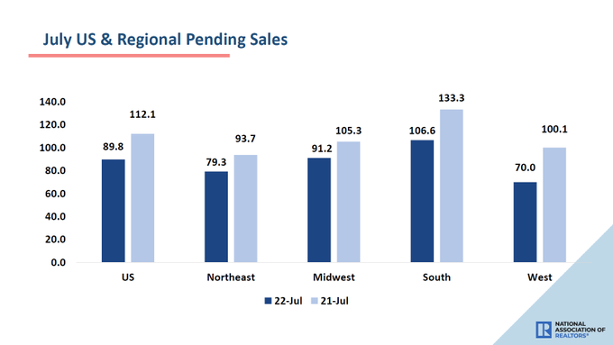
NAR Twitter
National Association of Realtors releases 2020/1 regional sales data. Although pending sales reduced by double digits in each region, the Midwest showed the least decline nationwide. The West led declines with an over 30% fall-off of new contract signings year over.
Further Reading:
Redfin CEO: Uncertain Times 8/29/22 - Marketwatch
Effects of slow housing on small business 8/27/22 – AP News
Blackstone alt investment pauses home buying 8/26/22 – Fortune

Matt Forcum
Shelby Realty Services
Effingham, IL
217.343.3400 Mobile

Data analysis and presentation by Matt Forcum for the purposes of general information and intended not for use as a client.

